We are looking for old used empty lick tubs… Free or very cheap.
Preferably ones without cracks, ones that hold water.

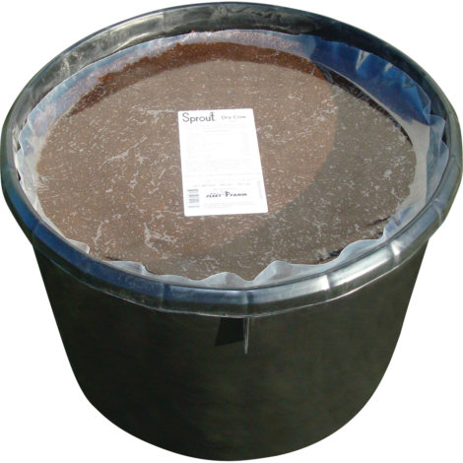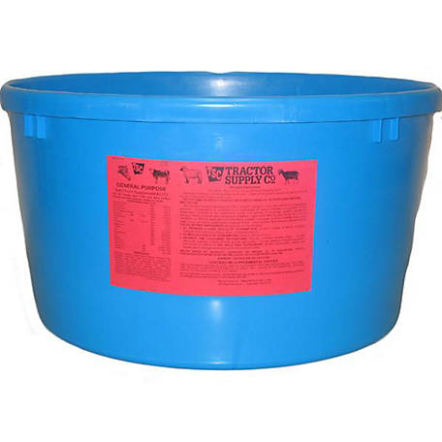

We are also seeking 30 & 55 gal barrels.
Mostly for rain water collection, fish and liquid composting.

DD&D Farms: 816.518.8804 & 417.876.7288
www.DavidDavidAndDavid.com

Even these are acceptable, but mostly looking for the ones above.
We will need these at a future date, not so much right now.

